## A000-Afr-Tanzania-Sukuma mask-19th c

## 

Case No.: 6

**Accession No.**

**Formal Label: Afr-Tanzania-Sukuma mask-19th c**

**Display Description:**

Sukuma traditional organized religion that worshipped god as the supreme being and creator of the universe was practiced within the confines of the family compound. The practice of Sukuma traditional religion does not take place in a structure like a mosque or church. Instead prayers are said among the family in the compound and are directed to the creator god in hopes of good rainfall and prosperity.In Kisukuma, Tanzania, there are several words for the creator god: Lyuba, Liwelelo, Lubangwe and Seba. Many of these names are associated with the sun. This does not mean that the Sukuma worship the sun, but rather that the creator god has attributes of the sun, such as shining over the earth and providing a life giving force.

The Sukuma people live in an area called Usukuma southwest of Lake Victoria, which is a few hundred miles south of the equator where annual temperatures range between 60-100o F. People raise cattle and farm and depend on the rains that extend from September through October and longer rains from February to May. This mask is of an ancestor who is invoked (in the sanctity of the family compound) along with the supreme being, the creator god, for health, rain and fruitful crops and animals. Note that the ears are carefully carved on this mask so that the ancestors and the creator god can hear the entreaties of the people. The creator god has attributes of the sun, such as shining over the earth and providing a life-giving force and has several names associated with the sun: *Lyuba, Liwelelo, Lubangwe* and *Seba*. The eternal spirits of deceased ancestors are believed to live in another realm and the family remembers them through special prayers and offerings of millet beer (*lwanga*), a mixture of millet seed and water and cattle dung symbolizing the family's the wealth in cows. When a family member dies, they are believed to watch over their descendants, so if an ancestor is not remembered through offerings, the family might encounter bad luck or even illness. For example, when a child is sick, the parents might consult a traditional doctor, or *nfumu* in Kisukuma. If the doctor attributes the cause of illness to angry or offended ancestors, the remedy might be for the family to give special offerings to appease the ancestor, or even to rename the child after the ancestor. Children are often renamed after ancestors during life-threatening illnesses. Another cure might be for the child to wear a necklace of beads with a central, triangular polished shell disk, called a *lupingu*, in honor of the child's ancestors. The belief in such remedies suggests that the ancestors or deceased relatives, have an ongoing relationship with their families. Therefore this mask is vital for the ancestors to both hearing entreaties and advising the living through a gifted medium who contacts the ancestors and hears and speaks on their behalf

**LC Classification:**

**Date or Time Horizon:**

**Geographical Area:**

**Map:**

**GPS coordinates:**

**Cultural Affiliation:**

**Media:** wood and kaolin clay

**Dimensions: H** 9.4 in, 24 cm

**Weight:**

**Condition:**

**Provenance:**

**Discussion:**

Those practicing Sukuma traditional religion honor the eternal spirit of deceased ancestors. When a person dies, many believe that their spirit continues on to live in another realm. The deceased person becomes an ancestor and the family remembers them through special prayers and offerings of millet beer and cow dung. Millet beer, a mixture of millet seed and water (called lwanga), represents the local brew of the ancestors. The cattle dung also recalls the ancestors through its reference to the wealth of a family with many cows and those ancestors who had cattle. When a family member dies, they are then in a position to watch over their descendants. It is believed that if the ancestor is not remembered through offerings, the family might encounter bad luck or even illness. For example, when a child is sick, the parents might consult a traditional doctor, or nfumu in Kisukuma. If the doctor attributes the cause of illness to angry or offended ancestors, the remedy might be for the family to give special offerings to appease the ancestor, or even to rename the child after the ancestor. Children in Usukuma are often renamed after ancestors during life-threatening illnesses. Another cure might be for the child to wear a necklace of beads with a central, triangular polished shell disk, called a lupingu, in honor of the child's ancestors. The belief in such remedies suggests that the ancestors or deceased relatives, have an ongoing relationship with their families.

## References:

Wijsen, Frans Jozef Servaas and R E S Tanner. 2000.*Seeking a good life : religion and society in Usukuma, Tanzania, 1945-1995*. **Nairobi, Kenya : Paulines Publications Africa.**

Appendix:

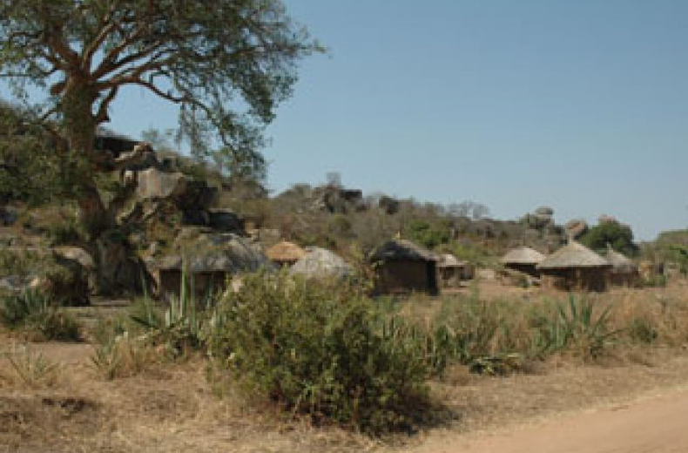Village of Sukuma, Tanzania, where this mask was made.

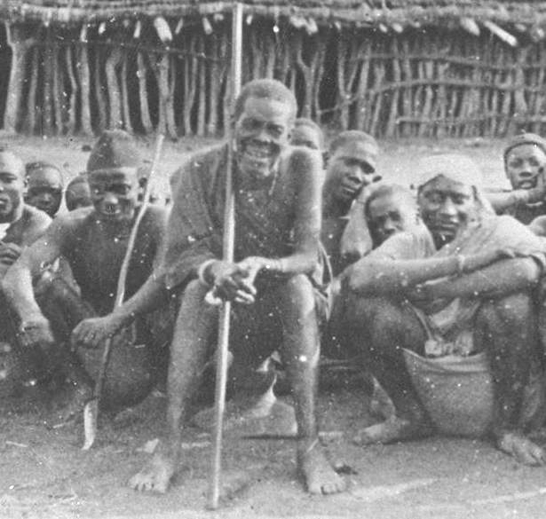

Archival photograph of Kikanga, the Ntemi (chief) of Bukumbi Chiefdom, c. 1900, Courtesy of the Archives of the Missionaries of Africa, Rome, sitting on chief's stool

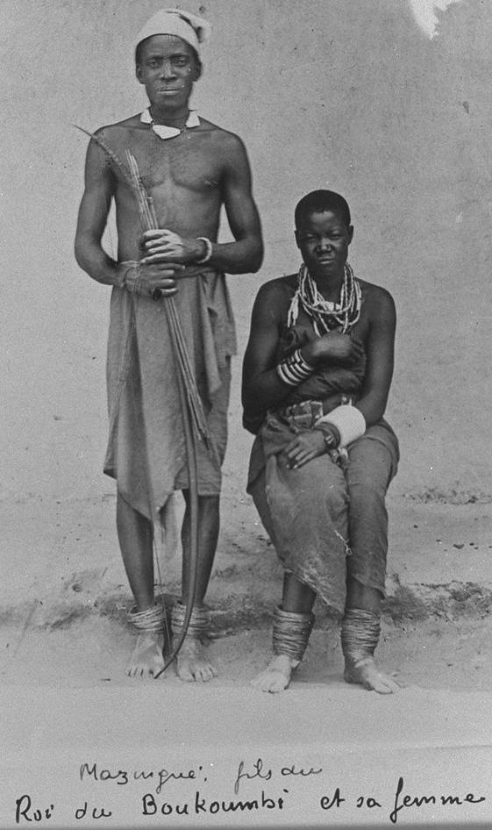 **Archival photograph**

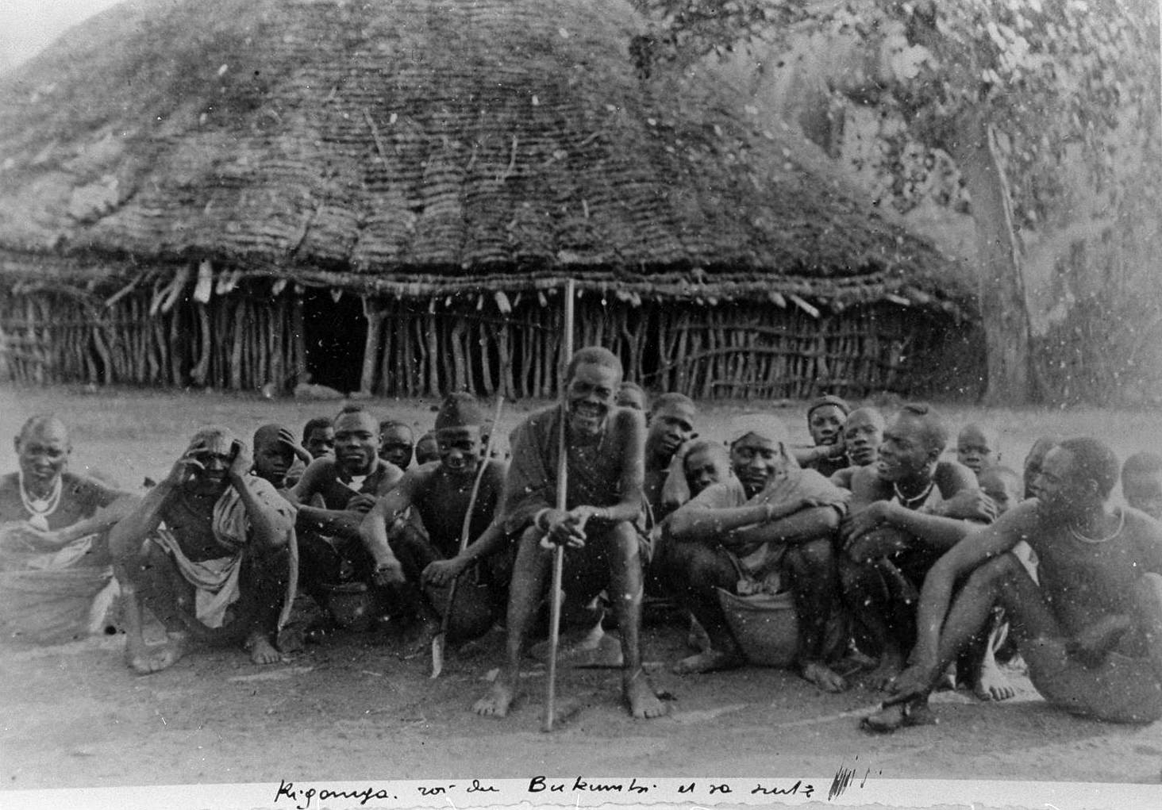 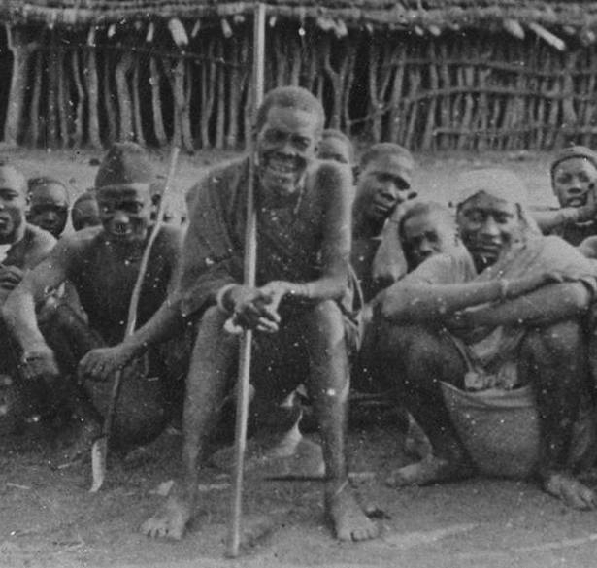

Archival photograph of Kikanga, the Ntemi (chief) of Bukumbi Chiefdom, c. 1900, Courtesy of the Archives of the Missionaries of Africa, Rome, sitting on chief's stool

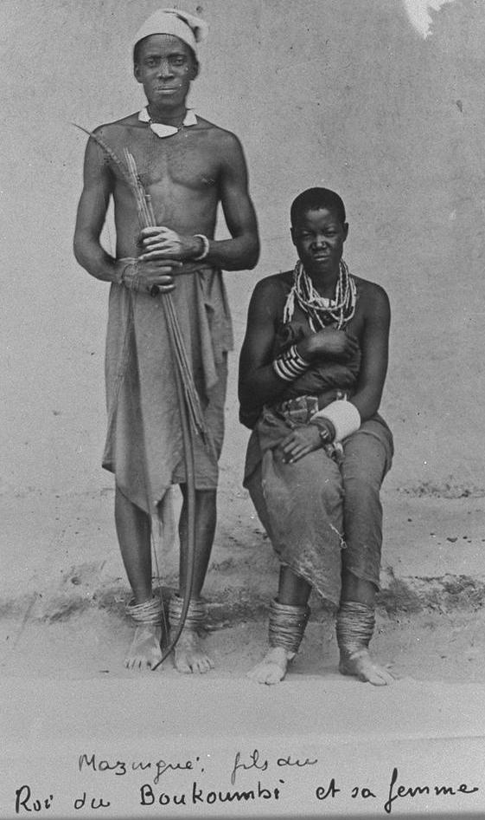 Archival photograph of Mazungu, the son of the Ntemi (chief) of Bukumbi Chiefdom, with his wife, c. 1900, Courtesy of the Archives of the Missionaries of Africa, Rome

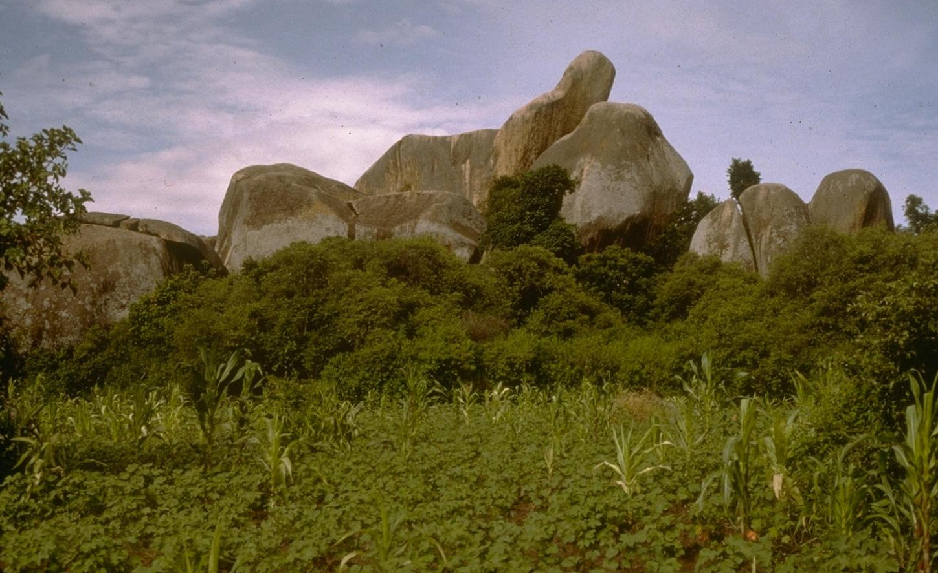

View of the grave sites of the chiefs of the Sukuma Chiefdom, April 7, 1995, Nyashigwe village

http://philip.greenspun.com/sukuma/pcd3536/nyashigwe-90.tcl

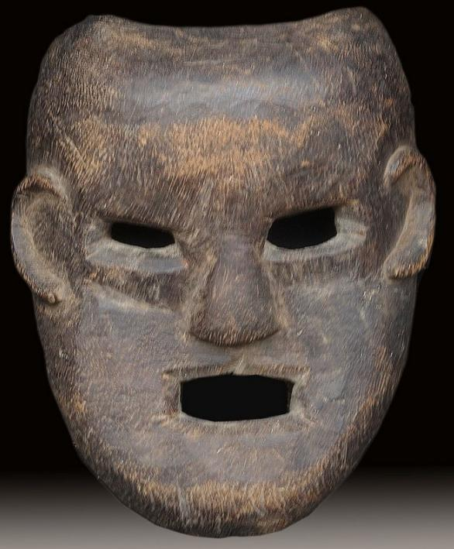 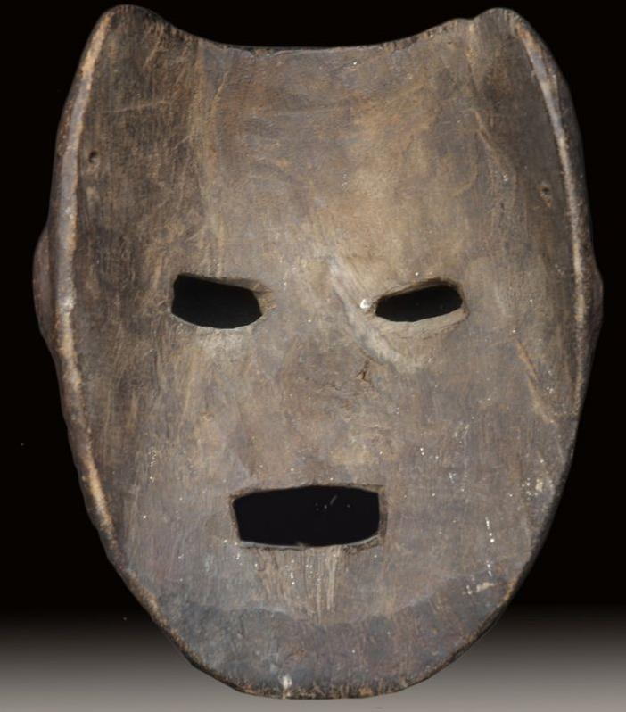

|  |  |
| --- | --- |
|  | [Sukuma](http://philip.greenspun.com/sukuma/) Culture and Tanzania by Mark H.C. Bessire  http://philip.greenspun.com/sukuma/intro |

The Sukuma culture is the largest in Tanzania. In many ways, the Sukuma are experiencing a renewed interest in traditional culture. Some think that the strength of this movement is found in the reconciliation of the modern and traditional. Cultural traditions appear to be spreading through contemporary means and not as a contest between the old and the new. Sukuma traditional arts and culture are thriving as much as the economic growth in the region.

Tanzania has accelerated its movement toward democracy, increased its communication networks, and opened its economy to the world. This has influenced the traditional culture of the Sukuma. While many Sukuma remain in small villages, others move to cities and assimilate to the urban society which is a combination of many different cultures and international influences. Possibly to renew awareness in Sukuma culture, identity and history, some people provide cultural leadership through a mix of traditional and modern culture. This movement reflects an increased interest in utamuduni or traditional culture, which lies in the dynamic social and political changes that are currently spreading through Usukuma. Today, a revival of Sukuma culture is taking place among traditional doctors, chiefs, artists, and dancers.

As the Tanzanian government has shifted from state controlled socialism to capitalism, it has created a more mobile work force and a diversification of employment opportunities. Many Sukuma are still farmers, merchants, builders and traditional doctors; but, in today's economy, there are also working in the communications, health, shipping, transportation, mining and banking sectors. Mwanza, the city center of Usukuma, is one of the largest and fastest growing urban areas in Tanzania. While most of Usukuma is rural and many live in the countryside, people throughout the country and central Africa are flocking to Mwanza to find work in one of the many emerging economic industries.

The Sukuma people live in an area called Usukuma which is located to the west and south of Lake Victoria, the second largest lake in the world. The area is only a few hundred miles south of the equator where there is a year round temperature between 60-100 degrees Fahrenheit. There are short rains from September through October and longer rains from February to May. After the early rains, the temperature rises until the heat is broken by the long rains in February. People depend on the rains to irrigate their fields and to provide water for their cattle.

|  |  |
| --- | --- |
|  |  |

The landscape of Usukuma is most notable for its kopje or rocky outcrops. Throughout the countryside and around Lake Victoria, these enormous rock formations are precariously balanced on top of each other. The land is very fertile in the north and near the lake, but dry to the south toward the city of Shinyanga. During a good rainy season, a family can produce enough food for the year.

For many in Usukuma, farming is a family activity. The Sukuma are known as cattle herders and most people farm the land for rice, cassava, potatoes and corn. Some also grow cotton as a cash crop. In rural areas, the cultivation of the farm, or shamba in Kiswahili, is a necessary part of daily life. During the cultivation season, when the land is prepared for planting, the family works together to ensure that they will harvest enough food for the coming year.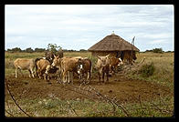

While men in rural areas generally farm or seek wage-paying jobs in larger towns, women have full time work maintaining the family needs. Yet many women also have full-time jobs. In larger villages and city centers, women also work as teachers, nurses, administrators and business women. If a woman works an additional job outside her daily work, she has little free time. For most women in the countryside, an ordinary day starts with a trip to search for firewood, then going to the well for the day's water supply, cooking ugali, a stiff porridge which is a staple of the Sukuma diet, walking to the market for supplies or grinding corn at the mill. Children help their mothers with the day's chores, such as going to the local well for water or sweeping the family compound.

In primary and secondary schools throughout the country children are taught Kiswahili. Tanzania is one of the only African countries to have been colonized by a European nation and not to have adopted the language of the colonizer. The Sukuma and all other Tanzanian cultures are closely united through the national language of Kiswahili which makes it easier for people from different linguistic groups to communicate with the other ethnic groups of Tanzania, the Sukuma also have their own language. Kisukuma is the first language learned by most Sukuma children; yet, they also speak Kiswahili. Kiswahili is spoken in Tanzania, Kenya, parts of Uganda, Zaire, Zambia and other countries and is one of the diplomatic languages of the United Nations.

|  |  |  |
| --- | --- | --- |
|  |  | **Tanzanian History and Politics** |

A common misconception is that Africa is a place without a long history and one which had no political structures before the Europeans formally colonized the continent. This is not true. Over many centuries African civilizations prospered and created strong cultural traditions and government structures that were maintained from generation to generation and leader to leader. The traditional Sukuma customs of today were formed in this way. Their history has been determined by their endurance and ability to assimilate cultural influences from Africa, Arabia, Europe and now America. During the Berlin Conference in 1890, European governments divided the continent to create the modern geographical map of Africa which has mostly survived until today. These geographical divisions did not take into account the traditional boundaries created by African languages, cultures and chiefdoms.

The chiefdoms in Usukuma began to consolidate in the 16th century. Early on, the Sukuma culture traded with neighboring chiefdoms such as the Baganda, in modern day Uganda. They also began trading with Arabs of the coast and Zanzibar in the 1800s. The first European contact with Usukuma came in 1857 when John Hanning Speke traveled from England to Lake Victoria. He was followed in the 1870s by the explorer Sir Henry Livingston and later by the English Anglican Church Missionary Society and the French Catholic Missionaries of Africa. But, it was Carl Peters who opened the way for the German East African Company to colonize what was to become Tanganyika. He did this through treaties that were signed with leaders and chiefs in order to exploit them for economic gain. The German colonizers were authoritarian and forced unfair laws on the local people. They governed by military force and their rule was challenged by numerous insurrections. The Germans were eventually forced out after their defeat in World War I. In 1918, Tanganyika Territory was placed under the British government who had already colonized Uganda and Kenya to the north.

In the early 1950s, under the leadership of Julius Nyerere, the Tanganyika Africa Association, a collection of farm cooperatives joined other political organizations to become TANU (Tanganyika African National Union). With the rallying call of "uhuru na umoja", "freedom and unity", Tanganyika gained its independence in 1961 and TANU's leader Nyerere became President of the country. Unlike other African movements toward independence, Tanganyika's transition was peaceful and without tribal conflict. In 1963, Zanzibar joined Tanganyika and the country became Tanzania, a combination of the names of each country. The most difficult task facing the new nation was to unite the country's numerous cultures as Tanzanians without destroying local identities or allowing certain groups to dominate others.

In 1967, the famous Arusha Declaration was proclaimed and President Nyerere's socialist policies of the state controlled economy and Ujamaa Village Program were put into action. These strategies were intended to bring rural people closer together to share limited technology, education and medical services within organized communal villages. The downfall of these initiatives was that people were forced to move from areas where their families had lived for generations to new villages without history or familiar surroundings. Most people did not like being moved forcibly by the government and local officials of the state controlled policies were sometimes 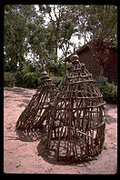corrupt. These two factors helped to undermine Tanzania's Ujamaa policy.

Tanzania has experienced many hardships since Independence. But the lasting legacy of the first President, Julius Nyerere, was his ability to forge a National identity through language and purpose - Kiswahili and modernization - without civil war. During the Independence period, Nyerere emphasized Socialism and National identity to fight the calamities of colonialism. Today, Julius Nyerere, known as Mwalimu, the teacher, is remembered for Tanzania's peaceful transition to Independence, the creation of Kiswahili as the national language, his enduring support of the African National Congress and Nelson Mandela against apartheid South Africa, and his assistance in freeing Uganda of the dictator Idi Amin.

In the 1980s Ali Hassan Mwinyi was chosen as president by President Nyerere and CCM (Chama cha Mapunduzi), the ruling political party. CCM developed from the original TANU when Tanganyika became Tanzania. In October of 1995 Tanzania held its first multi-party election and the CCM candidate Benjamin William Mkapa was elected. These presidents have relinquished the state controlled industries and have slowly embraced the open market systems of capitalism.

#### Religion in Usukuma

In Usukuma there is a diversity of religions. Many people practice traditional religion while others are Muslim and Christian. Before the arrival of Arab traders, Christian missionaries and colonial governments, the Sukuma had an organized form of religion which was practiced within the confines of the family compound. Those who practice traditional religion still worship god as the supreme being and creator of the universe. In Kisukuma there are several words for the creator god: Lyuba, Liwelelo, Lubangwe and Seba. Many of these names are associated with the sun. This does not mean that the Sukuma worship the sun, but rather that the creator god has attributes of the sun, such as shining over the earth and providing a life giving force. The practice of Sukuma traditional religion does not take place in a structure like a mosque or church. Instead prayers are said among the family in the compound and are directed to the creator god in hopes of good rainfall and prosperity.

Those practicing Sukuma traditional religion also honor the eternal spirit of deceased ancestors. When a person dies, many believe that their spirit continues on to live in another realm. The deceased person becomes an ancestor and the family remembers them through special prayers and offerings of millet beer and cow dung. Millet beer, a mixture of millet seed and water (called lwanga), represents the local brew of the ancestors. The cattle dung also recalls the ancestors through its reference to the wealth of a family with many cows and those ancestors who had cattle. When a family member dies, they are then in a position to watch over their descendants. It is believed that if the ancestor is not remembered through offerings, the family might encounter bad luck or even illness. For example, when a child is sick, the parents might consult a traditional doctor, or nfumu in Kisukuma. If the doctor attributes the cause of illness to angry or offended ancestors, the remedy might be for the family to give special offerings to appease the ancestor, or even to rename the child after the ancestor. Children in Usukuma are often renamed after ancestors during life-threatening illnesses. Another cure might be for the child to wear a necklace of beads with a central, triangular polished shell disk, called a lupingu, in honor of the child's ancestors. The belief in such remedies suggests that the ancestors or deceased relatives, have an ongoing relationship with their families.

##### Islam

The first Arab traders traveled to Lake Tanganyika in the middle of the Eighteenth Century and slowly moved north into Usukuma toward Lake Victoria. Islam influenced the coastal area of Tanzania as early as the Twelfth Century, but it did not take hold inland until Arab merchants had settled in trading camps. For the Sukuma, Islam is mostly centered in urban areas. In Mwanza there are several mosques with large congregations of both Sukuma as well as other cultures. In more remote villages, Sukuma Muslim communities assemble to pray in smaller mosques. Muslim worshippers all over the world regard Friday as the holy day and pray five times every day: at 6:00 a.m., 1:00 p.m., 4:00 p.m., 6:00 p.m. and 8:00 p.m. These daily prayers are called adhana. In many places a call to prayer can be heard at a distance over loud speakers from the tops of the mosques. This call is sung and reminds people to come to pray.

##### Christianity

In the 1870s Christian missionaries traveled from Europe to Tanzania. Both Catholic and Protestant missionaries, such as the Missionaries of Africa and Church Missionary Society, formed local missions in Usukuma. Church missions provided many services, such as primary schools for children, which attracted people to the religious communities where some converted to Christianity. Many of the early Protestant churches forbade the use of alcohol, tobacco and traditional practices such as dancing. The Catholic church did not prohibit the use of alcohol or tobacco and even permitted some traditional singing and dancing. Both churches forced people to renounce traditional religious beliefs as well as special objects associated with ancestor worship before conversion to Christianity. But today in Usukuma, local culture and songs are often used in the Christian religious services which occur on Sundays and sometimes daily. The Bujora Catholic Church represents one example of a church that is devoted to a mixture of Catholic religion and traditional Sukuma language, songs and dance.

##### The Bujora Church and Adaptation

|  |  |  |
| --- | --- | --- |
|  |  |  |

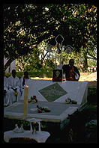The Bujora Church was founded in 1952 as a site where Sukuma traditions were used to teach the Catholic liturgy. The former Bishop of Mwanza, Josef Blomjous, selected the town of Kisesa for the experimental church. He sent the Canadian priest, Father David Clement, to learn about Sukuma culture and to teach Catholicism in a style that would be interesting to the Sukuma community. Father Clement, known as "Fumbuka Klementi" in Usukuma, formed a group of elders who called themselves Bana Sesilia (people of Sesilia, the Catholic patron saint of music) to conduct research on Sukuma traditions. They helped Father Clement to experience local culture and wrote many original Sukuma melodies with religious lyrics taken from the Bible. They also performed religious plays which taught large audiences about Christianity. Together the Bana Sesilia and Father Clement successfully integrated Sukuma music and dance into the Catholic ceremony.

Bujora remains an important center for adaptation. Adaptation is the teaching of the Catholic liturgy through indigenous cultural terms. Church services at Bujora include Sukuma music and dance. In addition, the Bujora Church is the first in Usukuma to be built in the shape of a traditional round house. The large, concrete Church is built in the round with a peaked, tin roof designed to resemble a thatched Sukuma dwelling. The Church is painted white with red, blue and black triangles decorating both the interior and exterior. The triangles represent the hoe, an important symbol in Usukuma for farming, which is associated with food and life. It has also been equated to the Catholic trinity of the Father, Son and Holy Ghost. The choice of the red, black and blue colors is also significant, according to the Bujora Parish Priest, Father Alex Mugonya. Black represents the people of Africa; blue, the color of Lake Victoria; and red, fire and life. Inside the Church, symbols associated with the Sukuma chiefs are used to signify God. The altar is built in the shape of a royal throne, a symbol of the chief's reign and chiefdom. The tabernacle, where the Eucharist or symbolic body of Christ is stored, is designed to resemble a chief's house with a shield and crossed spears on the door. This suggests that Christ of the Christian Church is to be compared to the power and reign of the Sukuma chief.

|  |  |  |
| --- | --- | --- |
|  |  |  |

Bujora has also maintained practices of adaptation during religious festivals. In several Catholic parishes in Usukuma, priests attracted the unconverted public during the Feast of Corpus Christi, a Catholic ceremony to celebrate the Eucharist. In the ceremony, flowers are thrown at the "body" of Christ at intervals during a long processional walk. Today, the Feast of Corpus Christi ritual is called Bulabo in Kisukuma, which means "flowers." The ceremony coincides with the beginning of the Sukuma dance season, which takes place from June to August after the harvest of local crops. This mix of Christian religion and traditional ceremony attracted many Sukuma individuals to Catholicism.

|  |  |  |
| --- | --- | --- |
|  |  |  |